***Bible Baptist Theological Seminary***

**Term Paper Formatting Guidelines**

1. Right hand justified--even edges on both sides of page.

2. 12 pt. in body, 11 pt in footnotes.

3. Double spacing throughout.  No triple space between paragraphs.

4. First line of footnote indented, second line not.

EXAMPLE

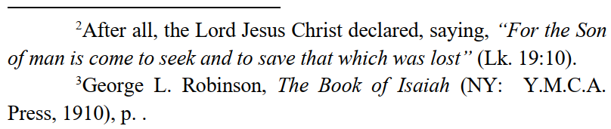

5. No bolding, not even Greek words.